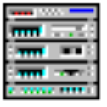 Media Rack
Introduction
Media Rack Overview
Media Rack gives you control over your PC’s audio functions through a user interface as simple to use as a home stereo system.

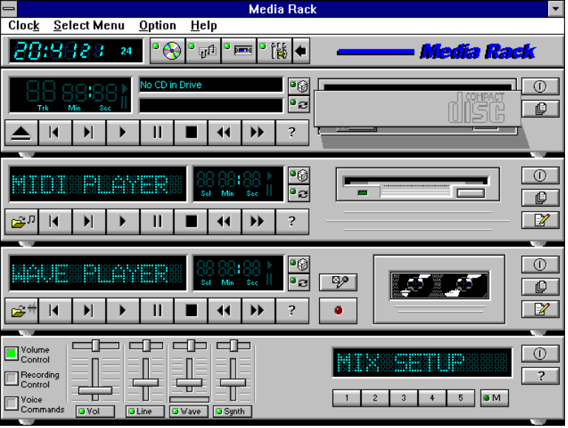
Media Rack Components
Media Rack consists of several major components:

Control Center: Controls the display of Media Rack's components.
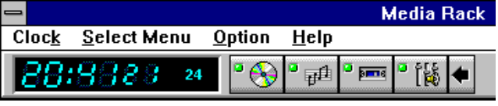
Alarm Clock: Speaks aloud the time and date, and plays your wave files as reminder alarms at times you set.
MIDI Player: Plays MIDI music files. Lets you create song playlists and use MIDI editors to modify the song files.
Wave Player: Records and plays digital audio (wave) files. Lets you create wave file playlists and use editors to modify the wave files.
CD Player: Plays standard audio CDs. Allows you to create playlist collections of CD tracks (songs).
System Mixer: Sets the volume level of your audio inputs and outputs.
Showing or Hiding Media Rack Components
To remove or add a component from display, click on the component's button on the Control Center’s Button Bar or toggle it off using the Select Menu menu.
Showing a Media Rack Component’s Menu
The left-most menu item changes to be that of the active component. For example, when using the MIDI Player, the left-most menu item will be MIDI. To make a component active, either click on the face of the component, or select the component from the Select Menu menu.
Selecting Full or Condensed View
Media Rack has a Full view, which covers a large portion of your PC's screen, and a Condensed view, which uses less space but still gives you access to most capabilities. To switch between them, click on the leftward- or rightward- pointing arrow button on the Button Bar.

Alarm Clock
Alarm Clock Overview
The Alarm Clock announces the time and date in a clear human voice, and can play a digital audio (wave) file at an alarm time you set.
Alarm Clock Configuration Preferences
The Clock menu offer several choices:
Say Time: Makes Alarm Clock immediately say the current time.
Preferences: The Options portion of the Preferences box lets you select how Alarm Clock tells you the time. The Alarm portion lets you set an audible reminder, using a .WAV file. The Color button lets you select the color in which Alarm Clock will display the time. Options include:
- Hour Format: In 12 hour format, Alarm Clock will say, e.g.: "The time is six-twenty-one-PM". In 24 hour format, you will hear "The time is eighteen-twenty-one".
- Say Date: If you enable this, Alarm Clock will follow the time by announcing, e.g., "Today is Thursday, January 12, 1995".
- Say Greeting: Causes Alarm Clock to precede the time and date with a greeting such as "Good Morning".
- Only When Asked: If selected, Alarm Clock will only say the time when you double-click on it or select Say Time from the Clock menu.
- On the Hour: Makes Alarm Clock speak at the start of the hour.
- On the Half Hour: Causes Alarm Clock to speak at the start of every hour as well as thirty minutes past the hour.
- On the Quarter Hour: Causes Alarm Clock to speak at the start of every hour as well as every fifteen minutes after that.
Color: Lets you select the color in which Alarm Clock displays the time.
Save Clock Preference on Exit: If this is not selected, your Preferences changes apply only until you close the program.
Exit: Closes the program.
Setting Alarms
To set Alarm Clock to play a wave file at a certain time:
1. Click on the On button in Alarm field of the Preferences box.
2. Type in, or Browse to, the wave file you want played.
3. Click on the Test button to hear your file, to make sure that when the time comes to play the file your system will be able to do so.
4. Specify the time you want the file played, by highlighting and typing into the Time fields.
5. Click on the OK button to accept the settings.
Testing Alarm Clock
Double-click on the clock's face at any time, or select Say Time from the Clock menu, to make Alarm Clock announce the time.
MIDI Player, Wave Player, and CD Player
Controls
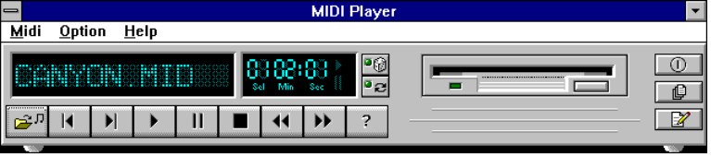
MIDI Player (above, similar to Wave Player and CD Player)
Current File or Track: The name of the current MIDI file, wave audio file, or CD track.
Counter: Shows several pieces of information:
- Sel (or Trk): If you have multiple selections in your playlist, this shows the number of the current selection or CD track.
- Min/Sec: For a newly loaded selection or one stopped by the Stop button, this displays the total length in minutes and seconds. When a selection is playing or paused, this displays elapsed time.
Shuffle/Repeat Buttons: When the Shuffle button is pressed, the selections in your playlist or CD will play in "shuffled" (random) order.
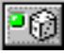
When the Repeat button is pressed, the selections in your playlist or CD (or the currently loaded file, if there is no playlist) will play repeatedly until stopped.
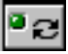
Choose File: Lets you select and load a single file.
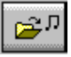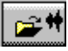
Open/Close CD: Opens or closes the door of your CD drive. Of course your DOS and Windows CD drivers must be properly installed.
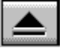
Previous/Next Selection: Moves to the beginning of the previous or next selection in your playlist or CD.

Play: Plays the current selection until: 1) the selection, playlist, or CD has finished, 2) you press the Stop or Pause button, 3) you load a different file, 4) you move to another selection, or 5) you close the program.

Pause: Temporarily stops playing the current selection. You can resume playing at the current location by pressing the button again.
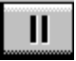
Stop: Stops playing the current selection and "rewinds" to the start.
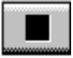
Scan: Moves your position ahead or back one second. Holding down a button shifts the position by ten seconds for every second you hold it.

Help: Shows the On-line User Guide for the selected component.
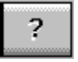
Format: Shows a list of formats in which you can record wave files.
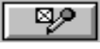
Record: Lets you record a wave audio file through your microphone or other current input device. (only on Wave Player).
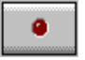
Power: Stops play, and hides the selected component from display.
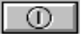
Playlist: Lets you create your own custom collections of audio selections, and specify the order in which selections play.
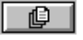
Edit: Launches an editor program, if available, so you can edit the current file.
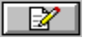
Playing a Single Audio Selection
1. Select what you want to play, as follows:
(For MIDI Player or Wave Player)
a. Click on the Choose File button or select Choose File from the component's menu, to bring up the Choose Files box.
b. In the Choose Files box, move among the directories to locate and highlight the file (file with a .MID extension for MIDI Player, or .WAV extension for Wave Player) to play. Click on OK. You should see displayed the name of the file.
(For CD Player)
a. Insert an audio CD into your CD drive. If CD Player recognizes it as one which you've previously described, it will display the name of the CD and its first track.
2. Press the Play button to start playing the selection.
Playing Multiple Selections Using a Playlist
Note: Playlist creation is described later.
1. Load the desired playlist, as follows:
(For MIDI Player or Wave Player)
a. Click on the Playlist button or select Edit Playlist from the player's menu.
b. Click on the Open button in the Edit Playlist box.
c. Move among the directories to locate and highlight the desired playlist file (file with a .MPL file extension for MIDI Player, or .WPL extension for Wave Player). Click on OK.
(For CD Player)
a. Insert an audio CD into your CD drive. If you’ve previously created a playlist for the CD, CD Player will display the name of the CD and its first track. If you haven’t created a playlist for the CD, CD Player will assume that the playlist consists of all the audio tracks (songs) on the CD, in their normal order.
2. To play in shuffled order or repeatedly, click on either or both of the player's Shuffle and Repeat buttons.
3. Click on the Play button to start playing.
Creating Playlists (MIDI Player or Wave Player)
With MIDI Player and Wave Player you can create "playlists" of files, letting you create your own “albums” to suit your needs.
To create or load a playlist:
1. Click on the Playlist button, or select Edit Playlist from the component's menu.
2. To load an existing playlist, click on the Open button and choose the playlist file you want to use (file with a .MPL extension for MIDI Player, or .WPL extension for Wave Player). Click on OK.
3. To create or edit a playlist, in the Edit Playlist window highlight each file you want, and add it by clicking on the Insert button. The file(s) will be added to the end of your playlist, or inserted immediately following any file you've highlighted in your playlist.
To add all the files, click on Insert All.
To delete files, highlight them and click on Remove .
To save your playlist to disk, click on Save As.
When finished, click on OK.
4. When you click on Play, you will play all the files in the playlist.
Creating Playlists (CD Player)
To create or load a playlist:
1. Click on the Playlist button, or select Edit Playlist from the CD menu. You will see CD Playlist window.
2. Type the CD's name in the CD Title field.
3. CD Player detects the tracks on the CD, and initially names them Track 1, Track 2, etc. Enter a more descriptive name for each by highlighting it in the left column, typing a new name in the Track Name field, and clicking on the Update Track Name button.
4. After naming the CD and its tracks you can also change the order in which the tracks play, described below, or finish now by clicking on OK to save this information for future use.
5. Unless you modify it, the playlist consists of all the tracks in the order they appear on the CD. You can create your own playlist for the CD, to skip over some songs or change their order:
- To delete tracks, highlight them and click on Remove.
- To add a deleted CD track back to the playlist, highlight it in the left column listing CD tracks and click on Insert. The track name will appear in the right column, either at the end of the list or immediately after a highlighted track name.
6. When you click on Play, you will play all the tracks in the playlist.
Recording Wave Audio
Wave Player lets you record and save your own wave files, as follows:
1. Choose an audio format to use, using the Format button or the Set Record Format menu item from the Wave menu.
2. Click on the Record button, or select Record from the Wave menu.
3. Speak into your microphone. You will see the Counter time indicators moving. When finished, click on the Stop button.
4. To play your new file, just click on the Play button.
5. To save your file, select Save Recording under the Wave menu.
6. After saving, the file name will show in the Current File window.
Note: You can record from sources other than your microphone (your CD drive or a device attached to your Line-In connector, for example). To change the audio source, use the System Mixer’s recording controls.
Choosing Wave Player Record Settings
Wave Player lets you record audio in different data formats, for different uses. Some data formats offer excellent sound quality, while others sacrifice sound quality but require less disk space.
To pick a recording data format:
1. Click on Wave Player's Format button, or select the Set Record Format menu item from the Wave menu.
2. Choose among the audio formats in the Set File Format window.
3. You can create your own audio format by typing a format name into the Name field and clicking on Save As.
System Mixer
System Mixer Overview
System Mixer lets you control all audio output and input levels.
The System Mixer's Controls
System Mixer displays the volume controls that your audio drivers make available. The names for these controls may vary.
Note: A choice of mixer control styles may be available through the Choose Style menu item of the Mixer menu.
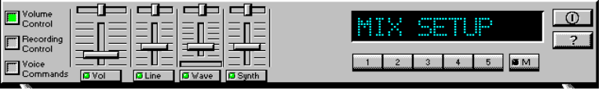
Volume Control: Clicking on this button shows and lets you use the output level controls.
Recording Control: Clicking on this button shows and lets you use the input level controls. (Note: many voice recognition applications use the Voice Commands input levels instead.)
Voice Commands: Clicking on this button displays and lets you use the input level controls reserved for voice recognition programs.
Input and Output Level Sliders and Buttons: For each input or output signal type, a control (for example, a vertical slider, or “fader”) controls the loudness, a horizontal slider controls balance between the two speakers, and the mute button temporarily stops input or output without changing slider positions.
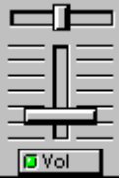
Note: A choice of mixer control styles may be available through the Choose Style menu item of the Mixer menu.
Control types and names vary. Some common types are listed below:
- Wave: Controls digital audio (wave) playback or record levels.
- Synth: Controls the MIDI music (music synthesis) play level.
- Line: Controls the audio hardware's Line In or Line Out levels. Line levels might be for an externally attached cassette player, e.g.
- CD: Controls the CD drive output level, for CD drives configured to play their audio output through the PC’s audio hardware.
- Vol: The master control for all outputs. The strength of an output signal is determined by both the Vol slider and the slider for the individual output. To affect all outputs, move the Vol slider. To change the output of an individual output type, move its slider.
- Mic: Controls the microphone input level.
Mute Buttons: Toggle between muting and enabling the signal. A button with a lit LED is enabled, while one with its LED not lit is muted. Several output signals can usually be enabled at once, while input signal types are often limited to a single active input.
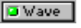
Settings Presets: Clicking on a Preset button loads an previously saved set of mixer settings. Presets buttons are numbered 1 to 5.
Memory Button: To save the current settings as a Preset configuration, press the memory button and then a Preset button.
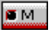
Current Settings Display: Shows the name of the current Settings Preset, if any, along with the Settings Preset button number.
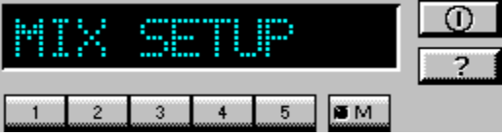
Note: Preset buttons and the Current Settings Display may not be shown on systems with a lot of controls, due to lack of space.
Power: Hides the System Mixer component from display.

Help: Shows the System Mixer's On-line User Guide.
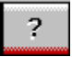
Setting Recording & Playback Levels
The controls for each signal type set that signal's level relative to others. The master Vol control affects all output signal types equally, and sets the overall output level. If, for example, the Wave and Vol levels are at half strength, wave audio output will be at one quarter strength.
To change signal levels for output and input:
1. Click on the Volume Control (for output levels), Recording Control (for most input levels), or Voice Commands (for some voice recognition program input levels) button at the left side of System Mixer to display the level controls.
2. Use your mouse or keyboard arrow keys to move each control to adjust the signal level. If you are playing or recording audio of that type, you should hear the volume level change as you move the control. You can also use keyboard “hotkeys” to control audio output volume at any time. To enable and select hotkeys, use the Hotkeys menu item from the Mixer menu.
3. Use your mouse or keyboard arrow keys to move the balance controls horizontally, left or right, to set relative level between the left and right channels.
4. To turn off (mute) a signal, click on its mute button. Muted controls do not display a lit LED light. To enable an input signal on systems that allow only a single input at once, click on the button beneath the input type so that its LED lights.

Notes: If you click on a control’s movement track, the control moves immediately to that point. To move the keyboard focus to a control, either click on it or use the Tab key. To move a control, use your mouse or your keyboard arrow keys. To center a control, press the spacebar.
Using Hotkey Output Level Controls
You can use keyboard key combinations to adjust the master output level, without using on-screen mixer controls. This lets you adjust output while keeping Media Rack minimized, e.g.
Using hotkeys, you can raise, lower, or mute the master output level. Each of these actions requires a combination of three keyboard keys pressed simultaneously. In each case, you hold down the [Ctrl] and [Alt] keys while pressing a third key. You can select the keys to represent these actions, and enable or disable the hotkey function, using the Hotkeys menu item from the Mixer menu.
Using System Mixer Presets
System Mixer stores up to five Preset configurations. Presets allow you to switch instantly to settings you've saved, appropriate for different purposes. For example, you might save one configuration for quietly recording reminders to yourself and another louder configuration for multimedia presentations.
Note: Preset buttons and the Current Settings Display may not be shown on systems with a lot of controls, due to lack of space. You can choose whether to display the preset controls with the Show Mixer Presets menu item from the Mixer menu. You can also choose the color for the Current Settings Display with the Color menu item from the Mixer menu.
To create a mixer configuration and assign it to one of the Presets:
1. Adjust the mixer settings, both input and output, as desired.
2. Click on the Memory button. You will see its LED lit, meaning it is ready to store your settings.
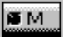
3. Click on one of the five Preset buttons.
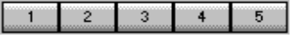
4. System Mixer will ask you to name the Preset configuration. The configuration name can be up to 10 characters in length.
To restore a settings configuration, just click on the desired Preset button. You should see the sliders move to the appropriate levels.
User Guide Contents
Media Rack Audio Control System
Introduction
Media Rack Overview
Media Rack Components
Showing or Hiding Media Rack Components
Showing a Media Rack Component’s Menu
Selecting Full or Condensed View
Alarm Clock
Alarm Clock Overview
Alarm Clock Configuration Preferences
Setting Alarms
Testing Alarm Clock
MIDI Player, Wave Player, and CD Player
User Controls
Playing a Single Audio Selection
Playing Multiple Selections Using a Playlist
Creating Playlists: MIDI Player or Wave Player
Creating Playlists: CD Player
Recording Wave Audio
Choosing Wave Player Record Settings
System Mixer
System Mixer Overview
The System Mixer's Controls
Setting Recording & Playback Levels
Using Hotkey Output Level Controls
Using System Mixer Presets

Media Rack and Willow Pond are trademarks of Willow Pond Corporation. Microsoft, MS, and MS-DOS are registered trademarks, and Windows is a trademark of Microsoft Corporation. Sound Blaster is a trademark of Creative Technology, Ltd. All other trademarks and registered trademarks are property of their respective holders and are hereby acknowledged.
Media Rack software and documentation are Copyright © 1995 Willow Pond Corporation. Portions are Copyright © 1993-1994 Digital Soup, Inc. All Rights Reserved.
Information in this manual is subject to change without notice.

